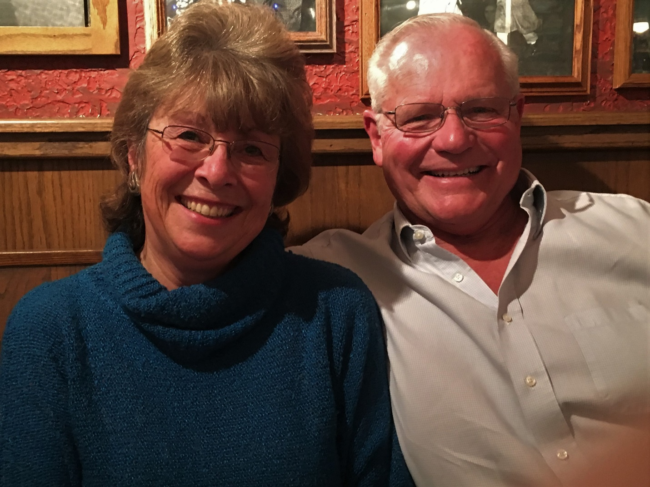

Ann Stevens

Eastlake High School Staff

Counselor 🡪 1992-2001

Asst Principal 🡪 2002-2007